Pokhara University

Level: Bachelor | Semester – Fall | Year : 2008
Programme: BE |  | Full Marks: 100
Course: Engineering Mathematics I |  | Time : 3hrs.

Candidates are required to give their answers in their own words as far as practicable.
The figures in the margin indicate full marks.

Attempt all the questions.

 | - If a function f (x) is derivable at a point x = c. Show that f(x) is continuous at x = c. By taking suitable example show that the converse may not be true.  OR  State Leibnitz theorem for successive derivative of the product of two functions. If y = (sin⁻¹ x)², prove that (1 – x²)y₂ – xy₁ – 2 = 0 and hence show that (1 – x²)y_{n+2} – (2n +1)xy_{n+1} – n²y_{n} = 0.  - State and prove Lagrange’s mean value theorem. Verify it, for f(x) = e^{x} in [0, 1]. | 8  7
 | - A cylindrical tin can closed at both ends with given capacity has to be constructed. Show that the amount of tin required will be minimum when the height is equal to the diameter.  OR  Define asymptotes of a curve. Find the asymptotes of  y³ + x²y + 2xy² – y + 1 = 0  - Evaluate 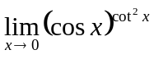 | 8  7
 | Evaluate Any Three  - 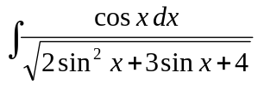  - 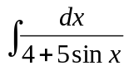  - 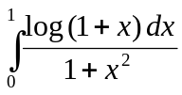  - Evaluate 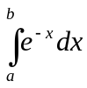 by summation method. | 3×5
 | - Find the area inside the circle x² + y² = 1 and the outside the parabola y² = 1 – x. Also sketch the bounded region.  OR  Find the volume of the solid generated by revolving the region bounded between x² = 4y and y = 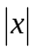, revolving about y = - 2.  - Find the approximate area by using Simpson's and trapezoidal rule for the region bounded by the curve y = x³, the x-axis, x = 0 and x = 2, with n = 4 and compare with exact value. | 7  7  8
 | - Define scalar triple product and prove geometrically that scalar triple product represents the volume of the parallelopiped. Also prove that in a scalar triple product the position of dot and cross can be interchanged.  - Find the equation of the plane through (3, 2, 1) and (1, 2, 3) which is perpendicular to the plane 4x – y + 2z = 7. | 8  7
 | - Define conic section by their eccentricity and classify them. Derive standard equation of parabola y² = 4ax.  - Find the condition, when the line lx + my + n = 0 touches the ellipse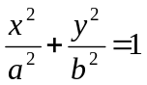. Also find their point of contact. | 7  8
 | Short questions:  - Find the radius of curvature of y = 4 sinx – sin2x at x =   - Find the foci of the hyperpola 9x² – 25y² = 225  - Find the length of the arc of the parabola y² = 4x from (0, 0) to (1, 2)  - Show that the vectors 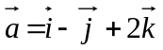, 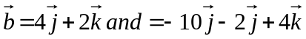are orthogonal.  - What will be the equation of the curve x² + y² – 10x – 12y + 36 = 0 if the origin is shifted to (5, 6)? | 5×2

